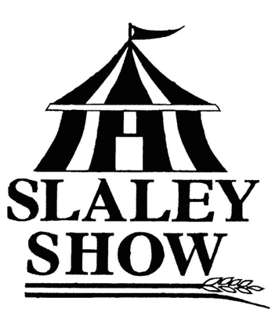
SLALEY SHOW
12th August 2023

MEMBERSHIP FORM
For the year beginning 1st January 2023

Membership benefits include: the right to vote at the AGM, notification of all events throughout the year, membership badge with free entry to the show, early schedules, designated parking area, complimentary hospitality and being part of your local village agricultural show.
NAME(S):
ADDRESS:
EMAIL:
I consent to be contacted by Slaley Show by the following method(s):
 | Email |  | Telephone |  | Post

Membership fee: £15.00 Life Members - Free Under 12 yrs - Free

Number of memberships required:

Please circle payment method:

BACS (Preferred) | Cheque
Sort code 30-94-19  Account number 00140729  Please quote your name as a reference | Made payable to:  Slaley Show
Donations for Slaley Show are welcome and much appreciated. Thank you.
£
- Through the Government’s Gift Aid scheme, Slaley Show can claim an additional 25p for every £1 you donate if you are a UK taxpayer. Please tick the box below to confirm and we will use your details provided above to claim Gift Aid.
I understand that if I pay less Income Tax and/or Capital Gains tax than the amount of Gift Aid claimed on all my donations in that tax year then it is my responsibility to pay the difference.

SIGNED ………………………………………………………………………………….. DATE………………..……

Please return this form and payment to: Hilary Chalmers, Slaley Show, c/o Cedar Lodge, Slaley, NE47 0AD
or email to: membership.slaleyshow@hotmail.com

Registered charity no. 505028
Slaley Show Society Members and Stakeholders
The General Data Protection Regulation (GDPR). This is a law that gives everyone more control over their data and how it is used, and it is important that we ensure that your data is handled correctly. We have updated our privacy policy in line with the requirements set out by the General Data Protection Regulation. If you DO NOT wish to continue to communicate with the Slaley Show Society or if you want to see a copy of our policy, please contact The Secretary.

